Section D — AI-Augmented Learning
STEP 2 · TEST & DEBUG ( WITHOUT AI)
Then, working without AI, test the code using boundary inputs: (a) all 10 values identical, (b) a mix of positive and negative integers, and (c) a list where the mean falls exactly between min and max. Find at least one bug, edge-case failure, or improvement in the AI's solution and fix it yourself.
Program-
#include <stdio.h>

int main()
{
int numbers[10];
int i, j, temp;
int max, min;
int sum = 0;
float mean;
float distanceMin, distanceMax;

printf("Enter exactly 10 integers:\n");

/* Accept exactly 10 integers */
for (i = 0; i < 10; i++)
{
printf("Enter integer %d: ", i + 1);
scanf("%d", &numbers[i]);
}

/* Find maximum, minimum and sum */
max = numbers[0];
min = numbers[0];

for (i = 0; i < 10; i++)
{
sum = sum + numbers[i];

if (numbers[i] > max)
{
max = numbers[i];
}

if (numbers[i] < min)
{
min = numbers[i];
}
}

/* Corrected mean calculation */
mean = (float)sum / 10;

printf("\nMaximum value: %d\n", max);
printf("Minimum value: %d\n", min);
printf("Arithmetic Mean: %.2f\n", mean);

/* Sort array in ascending order using Bubble Sort */
for (i = 0; i < 9; i++)
{
for (j = 0; j < 9 - i; j++)
{
if (numbers[j] > numbers[j + 1])
{
temp = numbers[j];
numbers[j] = numbers[j + 1];
numbers[j + 1] = temp;
}
}
}

/* Display sorted array */
printf("\nSorted array in ascending order:\n");

for (i = 0; i < 10; i++)
{
printf("%d ", numbers[i]);
}

/* Calculate distance of mean from minimum and maximum */
distanceMin = mean - min;
distanceMax = max - mean;

printf("\n\nMean position analysis:\n");

if (distanceMin < distanceMax)
{
printf("The mean is closer to the minimum.\n");
}
else if (distanceMax < distanceMin)
{
printf("The mean is closer to the maximum.\n");
}
else
{
printf("The mean is exactly midway between the minimum and maximum.\n");
}

return 0;
}
Output-

- all 10 values identical
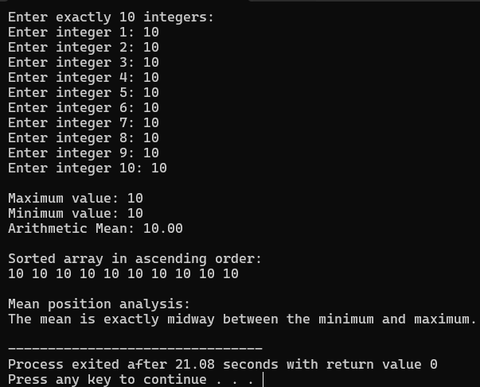

- a mix of positive and negative integers
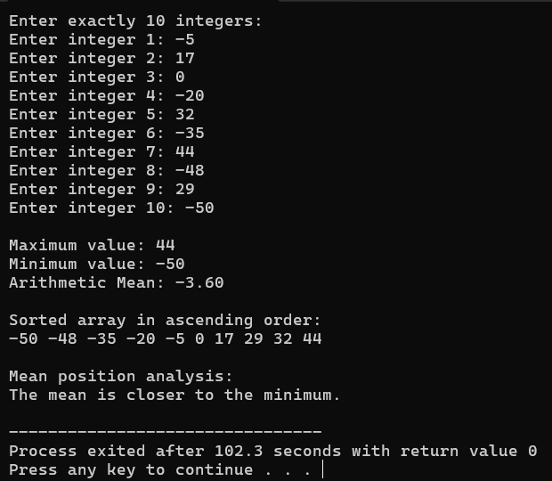
- a list where the mean falls exactly between min and max. Find at least one bug, edge-case failure, or improvement in the AI's solution and fix it yourself.
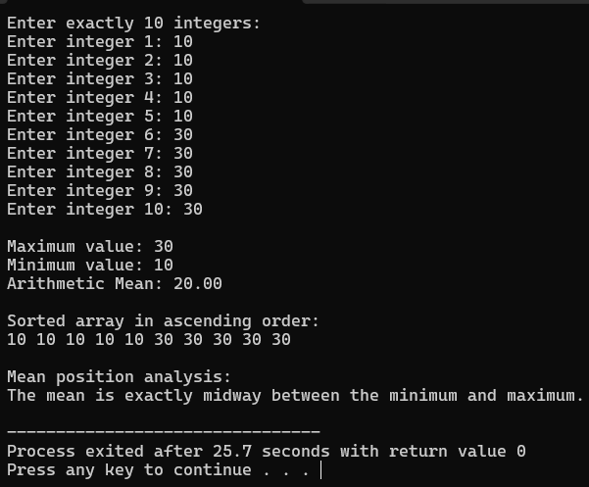

I tested the program with identical values, positive and negative integers, and values where the mean was exactly midway between the minimum and maximum. I found that the AI's original code used integer division in mean = sum / 10, which could remove the decimal part of the mean. I corrected it to mean = (float)sum / 10 so that the mean is calculated accurately as a float with two decimal places.

